🪲 Pest Detection Using Deep Learning (MobileNetV2 Transfer Learning Model)

1. Introduction
In agriculture, pest infestation is a major challenge that reduces crop yield and affects food production. Traditional pest identification methods rely on human expertise, which can be time-consuming, inconsistent, and limited in scale.
To address this, the Pest Detection AI System is developed using Deep Learning and Transfer Learning. The model automatically identifies different types of pests from images, improving detection speed and accuracy while reducing the dependency on manual classification.

2. Objective
The main goal of this project is to design and develop an AI-based pest detection system capable of classifying pest species using images.
The specific objectives are:
- To preprocess and augment pest image datasets.
- To apply MobileNetV2 as a transfer learning backbone for feature extraction.
- To fine-tune the model for higher accuracy.
- To evaluate the model using test accuracy.
- To deploy the model using Gradio interface for easy user interaction.

3. Dataset Description
- Dataset Name: Pest Dataset
- Dataset link: https://www.kaggle.com/datasets/simranvolunesia/pest-dataset
- Pests are a huge threat! Farmers are hard at work however their productivity is reduced due to pests, so this dataset can be used to identify pests or maybe other use cases involving pest identification.
- Dataset Description
a. Type of dataset: Image Dataset
b. No. of training images: 300 images per pest
c. No. of testing images: 50 images per pest
d.Data Source: Automatic script to scrape images of pest from Google through Selenium and Chrome Driver
e. Pests: aphids, armyworm, beetle, bollworm, grasshopper, mites, mosquito, sawfly, stem borer
- Structure:
  - /train → Used for training and validation (split internally 80%-20%)
  - /test → Used for model testing
- Number of Classes: 9 pest classes
  - Aphids
  - Armyworm
  - Beetle
  - Bollworm
  - Grasshopper
  - Mites
  - Mosquito
  - Sawfly
  - Stem borer
- Image Dimensions: 224 × 224 pixels
- Total Images: Approximately 450 images in the test set
- Data Type: RGB images

4. Methodology

Step 1: Dataset Upload and Extraction
The dataset ZIP file was uploaded and extracted in Google Colab using:
from google.colab import files
uploaded = files.upload()
and then unzipped using Python’s zipfile module.

Step 2: Data Preprocessing and Augmentation
To increase dataset diversity and prevent overfitting, several augmentation techniques were applied:
- Rotation (20°)
- Width and height shift (0.2)
- Shear and zoom transformation
- Horizontal flipping
All images were normalized by scaling pixel values between 0 and 1 using rescale=1./255.

Step 3: Model Architecture (Transfer Learning with MobileNetV2)
A pre-trained MobileNetV2 model (trained on ImageNet) was used as the base model with:
- include_top = False → excludes the classification head
- input_shape = (224, 224, 3)
Custom layers were added on top:
- Global Average Pooling Layer
- Dense Layer (128 units, ReLU activation)
- Dropout Layer (rate = 0.6) for regularization
- Output Layer (Softmax) with number of units = number of pest classes

Step 4: Model Training
The training was performed in two stages:
- Initial Training (Feature Extraction Phase):
  - Base layers frozen (layer.trainable = False)
  - Only top layers trained for 10 epochs
  - Learning rate: default Adam (0.001)
- Fine-Tuning Phase:
  - Last 20 layers of the base model unfrozen
  - Model recompiled with a smaller learning rate (1e-5)
  - Trained for 5 more epochs
Callbacks used:
- EarlyStopping: Stops training if no improvement in validation loss for 3 epochs.
- ReduceLROnPlateau: Reduces learning rate by 0.3 when validation loss plateaus.

5. Results and Analysis

Training and Validation Performance

Metric | Value
Training Accuracy | 89.35%
Validation Accuracy | 78.15%
Final Test Accuracy | 92.89%
Test Loss | 0.3561
Interpretation:
- The training and validation accuracy are close, showing the model is not overfitting severely.
- Fine-tuning improved generalization and boosted test accuracy beyond 90%.
- The model successfully learned discriminative pest features.

6. Model Evaluation
The final test evaluation was performed on an unseen test set:
Final Test Accuracy: 92.89%
This confirms that the model generalizes well to new data.

7. Model Deployment Using Gradio
A Gradio web interface was developed for real-time pest prediction.
Users can upload a pest image, and the trained model predicts the pest type instantly.

8. Conclusion
The developed Pest Detection AI System demonstrates that transfer learning with MobileNetV2 is an efficient approach for classifying pest images with limited data.By combining data augmentation, fine-tuning, and proper regularization, the model achieved ~93% accuracy, showing strong potential for real-world agricultural applications.

9. Future Enhancements
- Expand the dataset to include more pest species.
- Integrate the model into a mobile application for field use.
- Implement object detection to localize pests within an image.
- Explore lightweight models (e.g., EfficientNet-Lite) for edge deployment.
10. References
https://www.kaggle.com/datasets/simranvolunesia/pest-dataset

11. Output

  - Aphids
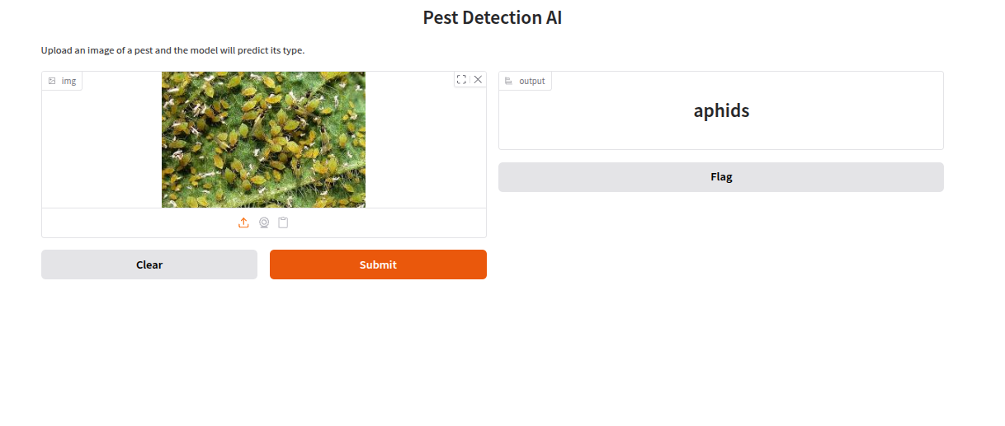

  - Armyworm

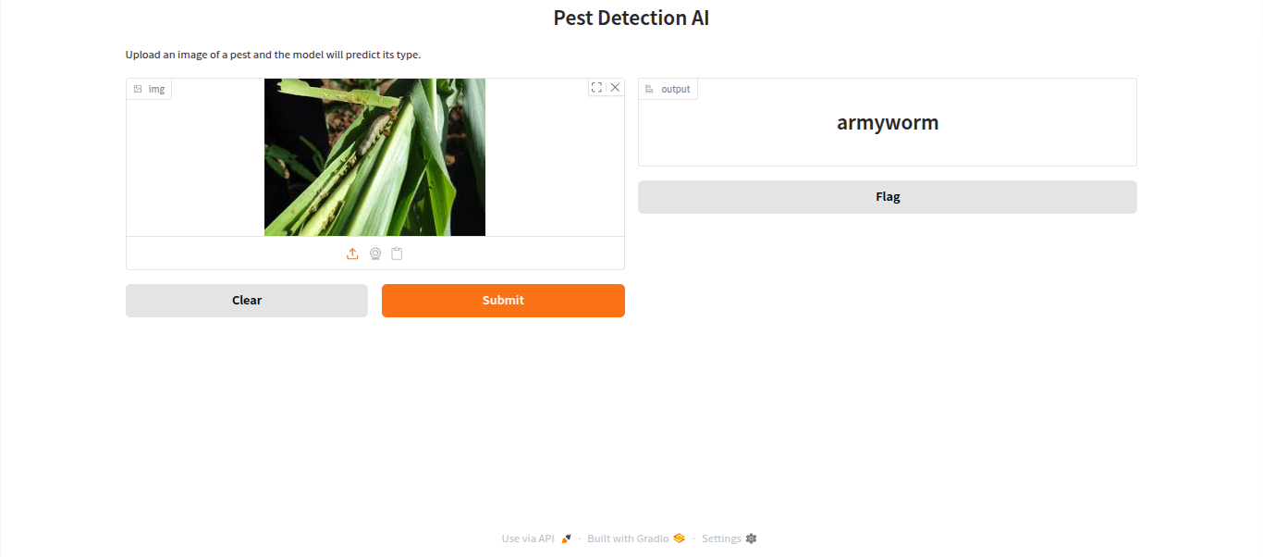
  - Beetle
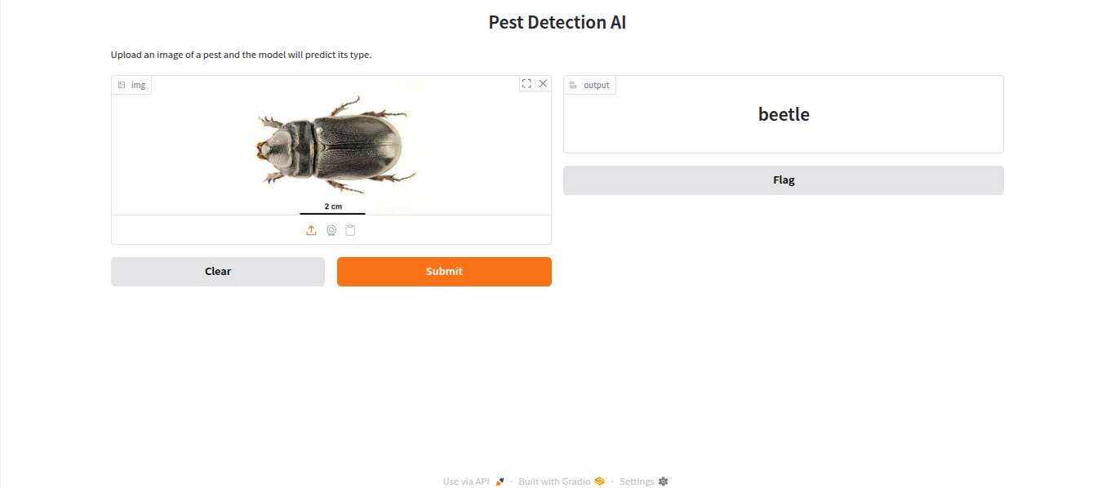

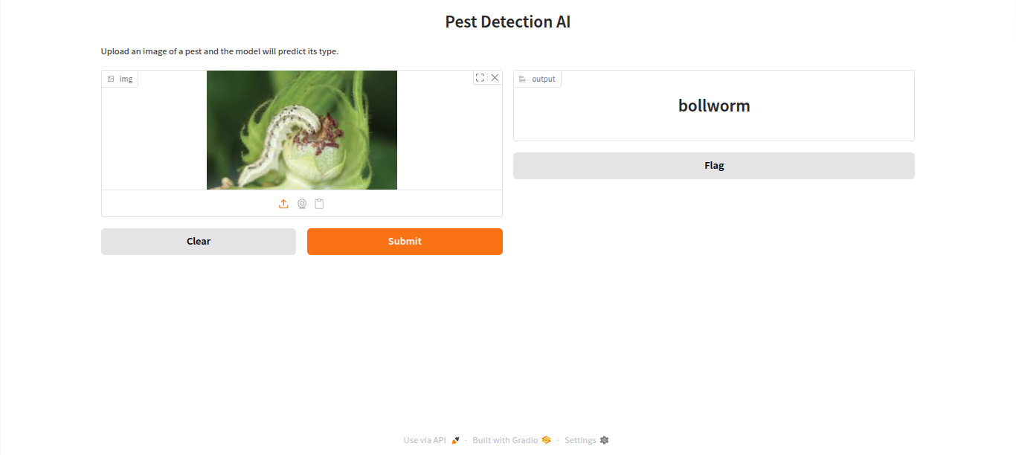
  - Bollworm

  - Grasshopper
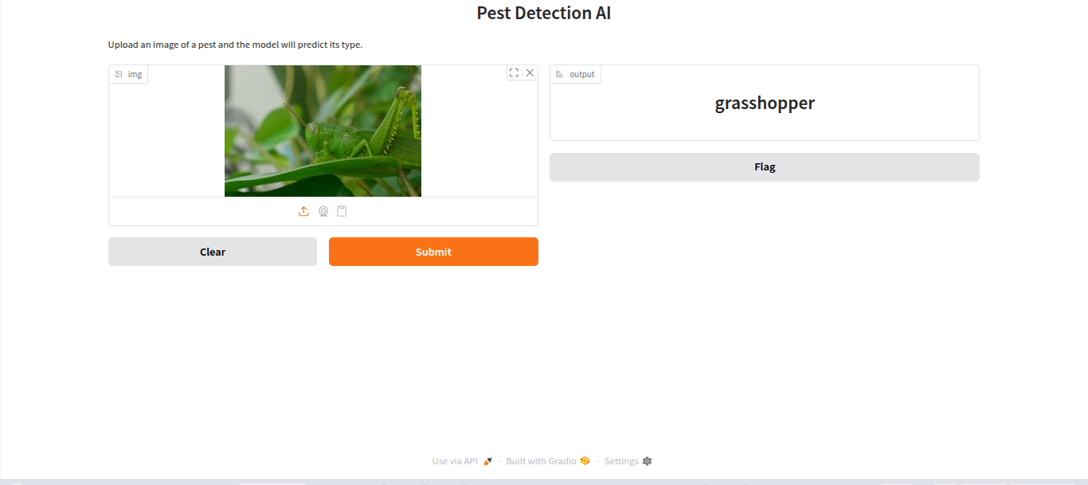

  - Mites

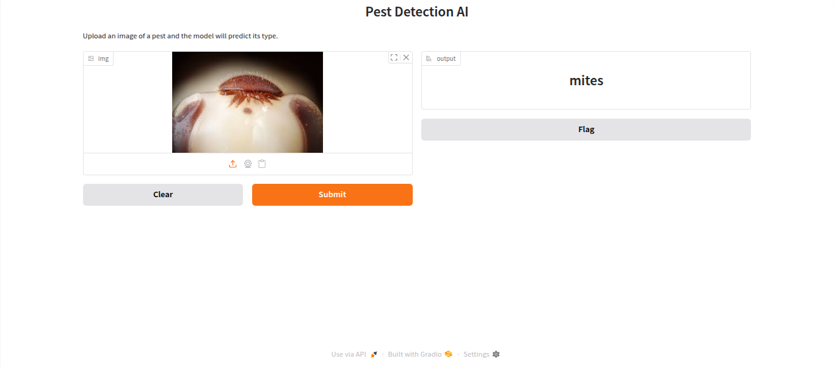
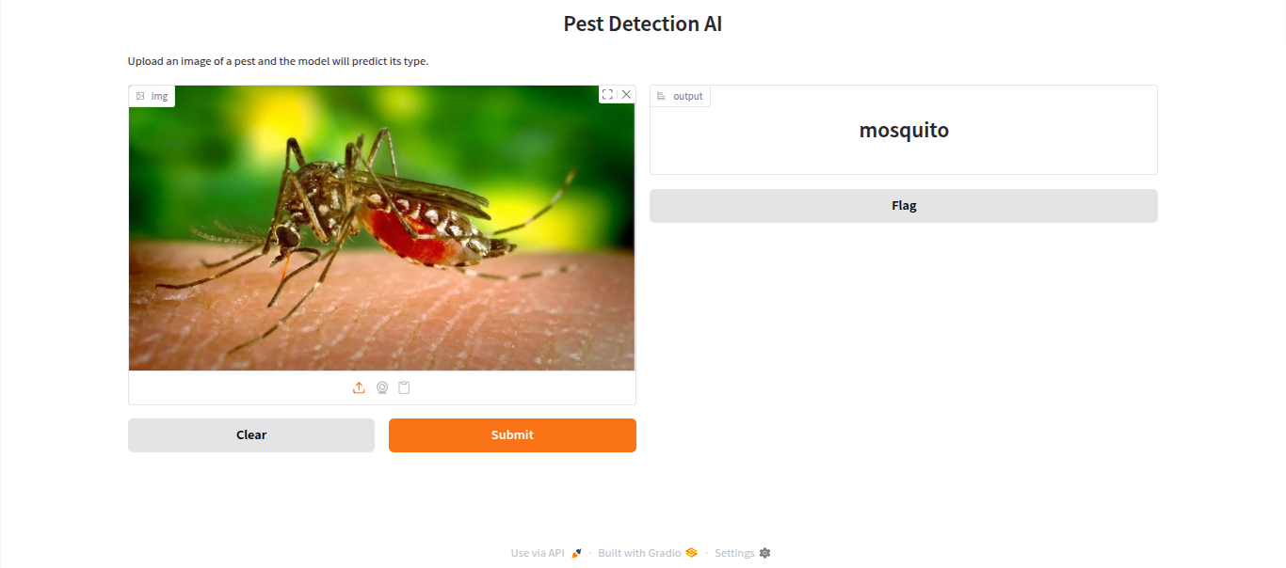
  - Mosquito

  - Sawfly
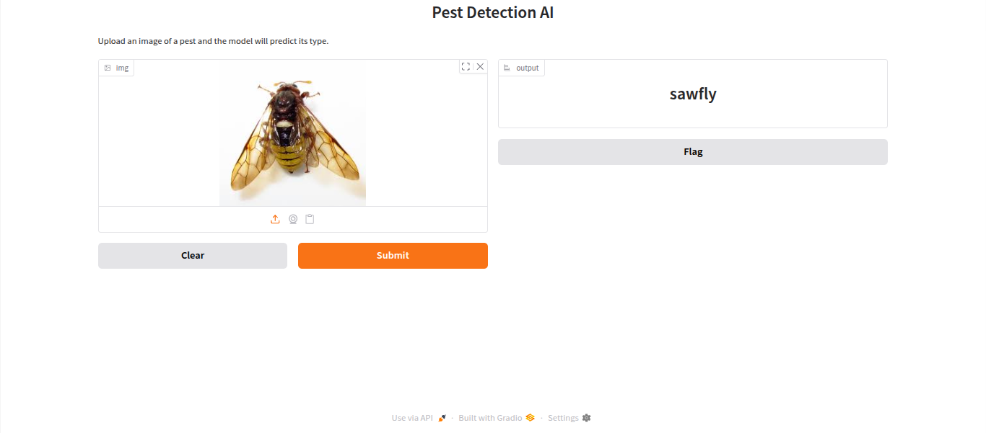

  - Stem borer

